

WEB DEVELOPMENT WORKFLOW

Project Report submitted in partial fulfillment of the requirements for the award of the degree of

BACHELOR OF COMPUTER APPLICATIONS

Submitted By

Chaitra K

25BCAB16

Under the guidance of

Dr Dhana Malar

SCHOOL OF COMPUTATIONAL AND PHYSICAL SCIENCES
DEPARTMENT OF COMPUTER SCIENCE
BCA/B.Sc PROGRAMME

KRISTU JAYANTI [Deemed to be University]
K. Narayanapura, Kothanur P.O., Bangalore – 560077



DEPARTMENT OF COMPUTER SCIENCE

CERTIFICATE OF COMPLETION

This is to certify that the project entitled PORTFOLIO has been satisfactorily completed by 25BCAB16, Chaitra K in partial fulfillment of the award of the Bachelor of Computer Applications degree requirements prescribed by Kristu Jayanti [Deemed to be University] Bengaluru during the academic year 2025 -26.

Internal Guide Head of the Department



DECLARATION

I, 25BCAB16, Chaitra K hereby declare that the project work entitled PORTFOLIO is an original project work carried out by me, under the guidance of Dr Dhana Malar

Signature
Chaitra K

Bengaluru Date: 26/03/2026

TABLE OF CONTENTS

Sl. No | Topics | Pages
1 | Introduction
2 | Tools and Technologies used
3 | Modern Web Development Workflow
4 | Screenshots
5 | Conclusion
6 | References

INTRODUCTION

This Project represents a comprehensive full-stack web development solution that combines modern design principles with robust backend functionality. The Professional Portfolio Website is a responsive, feature-rich application designed to establish a strong digital presence while effectively capturing and managing client inquiries.

Built using HTML5, CSS3, and JavaScript on the frontend, with Mongodb,Node.js and Express.js powering the backend, this project demonstrates proficiency across the entire development stack.

The application showcases contemporary web technologies including glass morphism design patterns, real-time form validation, and automated data management systems. By integrating a sophisticated contact management system that stores all submissions in a structured JSON database, the project serves dual purposes: it functions as a powerful lead generation tool for business professionals while simultaneously demonstrating advanced software engineering practices including security protocols, error handling, API design, and responsive user interface development.

The portfolio not only presents professional skills and project experience in an aesthetically pleasing manner but also includes operational features that make it suitable for actual business deployment, making it an ideal intersection of practical application and technical learning.

Tools and Technologies Used

Section | Tools and Technology
Frontend | HTML5, CSS3, JavaScript details
Backend | Mongodb ,Node.js, Express.js configuration
Data Storage | JSON file system explanation
Development Tools | VS Code, Git, Browser
Design Patterns | Glassmorphism, responsive design
Security | CSP, validation, CORS
API Reference | 6 endpoints documented
Performance | Optimization techniques
Technology Stack Summary | Table with all tools
Interaction Flow | Diagram showing how everything connects
Learning Outcomes | 10 skills demonstrated

Modern Web Development Workflow
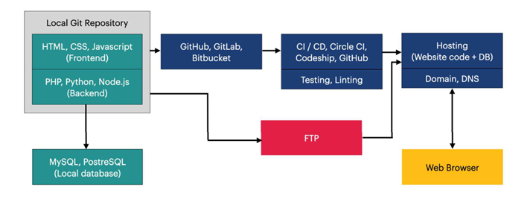

- First we have to create web page or frontend ( i.e. user interface) using HTML, CSS, JAVA SCRIPT.

- And we have to check if it’s working properly in local server.

- Next, we have to push it to GitHub , GitLab or Bitbucket.

- CI / CD testing and fixing the error in the code.

- Hosting the website using Render or vercel . with webpage and database in server.

- And the webpage is ready to run in server and the entered data should store in MongoDB Atlas.

Screenshots

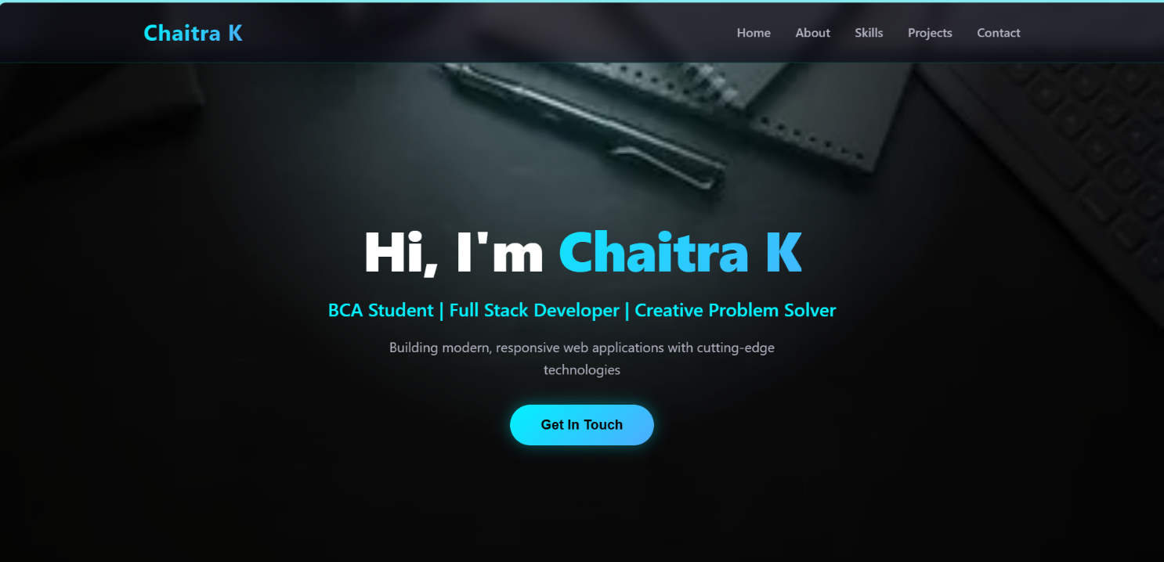
Website (Front End) : Website Link: http://localhost:3000

Backend Data Storage ( Mongodb )

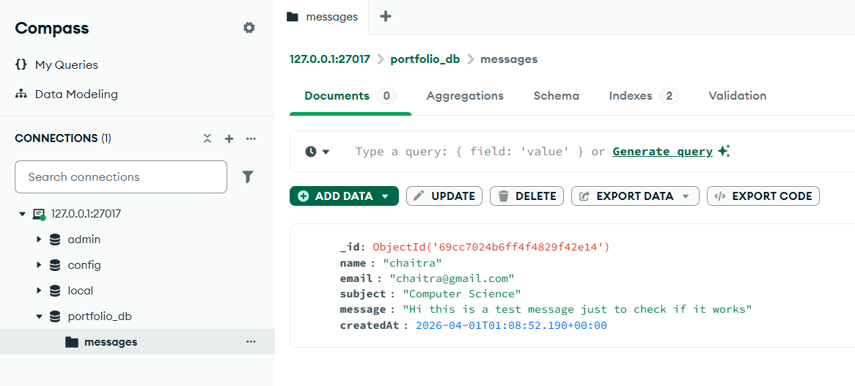

My GitHub Repository

GitHub Link:

https://github.com/25bcab16-jpg/Web-Development-Workflow.git

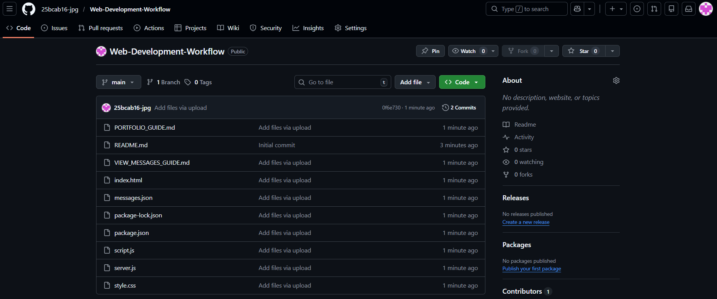


Conclusion

The Professional Portfolio Website project successfully demonstrates comprehensive full-stack web development capabilities by combining modern design aesthetics with robust backend functionality. This fully functional application showcases proficiency across the entire development stack—from responsive HTML5/CSS3 frontend design to Mongodb,Node.js/Express.js backend implementation.

Technical Excellence:
By utilizing vanilla JavaScript and pure backend technologies without heavy frameworks, the project remains lightweight, portable, and educational. The emphasis on security (CSP headers, input validation), responsive design (mobile-first approach), and professional standards reflects industry best practices.

The project successfully bridges theoretical programming knowledge with practical web application development, demonstrating that sophisticated functionality combined with professional design creates valuable, deployable solutions.

References

- MDN Web Docs - https://developer.mozilla.org

(HTML5, CSS3, JavaScript, Fetch API, CORS, CSP)

- Express.js - https://expressjs.com/ (Routing, middleware, static files)

- npm Docs - https://docs.npmjs.com/

(Packages: express v5.2.1, cors v2.8.6)

- Glassmorphism - https://glassmorphism.com/ (Frosted glass UI design)

- Google Material Design - https://material.io/design/ (Color theory, spacing)

